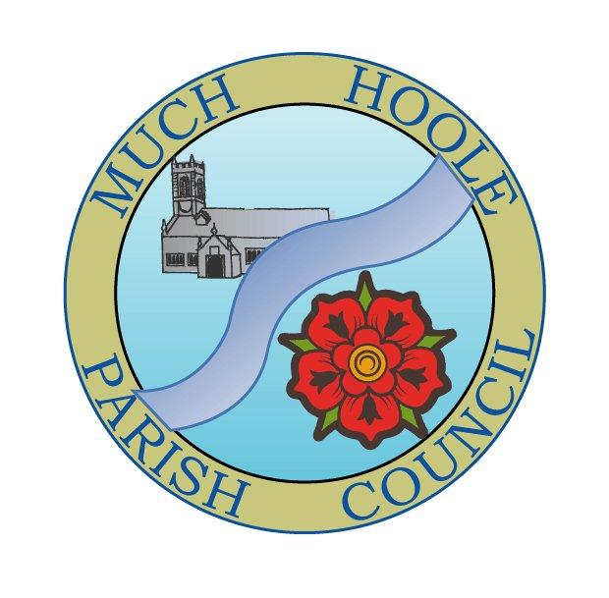 | MUCH HOOLE PARISH COUNCIL  NOTICE OF MEETING
You are hereby summoned to attend the Meeting of Much Hoole Parish Council to be held at 7.30pm on Monday 12th December 2022. The meeting will be held at the Venue (Hoole memorial village hall) Liverpool Road.
Russ Weaver, Clerk

AGENDA
1. | Apologies for Absence  To receive apologies for absence.
2. | Declaration of Interests and Dispensations  - To receive declarations of interest from Councillors on items on the agenda  - To receive written requests for dispensations for disclosable pecuniary interests (if any)  - To grant any requests for dispensation as appropriate
3. | Minutes of the Previous Meetings  To resolve to approve as a correct record the Minutes of the Council Meeting held on the 14th November 2022
4. | Public Time  To invite and listen to issues raised by members of the public.
5. | Reports from other meetings  The Council will receive reports from meetings where Councillors have attended as representatives.
6. | Off Road Cycle Track  To consider any updates on the Cycle track and resolve any actions required.
7. | Finance and Audit  To resolve to authorise payment of the following:  - To resolve to pay the Clerk in the sum of £673.60 (Net pay for October and November, plus backdated pay to 1st April at revised NJC rate)  - To resolve to pay HMRC in the sum of £168.40 in respect of payments at item a) above  - To resolve to pay Cllr R Lea £498.06 for re-imbursement of printing costs to Sprintprint in sum of £340, purchase of Union flag from Hampshire Flag Company in sum of £158.06. (Both of these items were agreed in principle at the last meeting  - To resolve to pay S.Raby in the sum of £510 for supplying Christmas trees (for 2021 and 2022 as agreed in principle at the last meeting)  - To resolve to pay Royal British Legion in sum of £28.00 for supplying commemorative wreath  - To resolve to pay Signs of the Times in sum of £8643.00 for village artwork  - To resolve to appoint JDH Business Services Ltd auditors as internal auditors for 2022/23 at a fee of £225 plus VAT  - To note PKF Littlejohn LLP have been re-appointed as external auditors for the next three years
8. | Planning  07/2022/00852/CLU 15 Town Lane, Much Hoole, Preston, Lancashire, PR4 4GJ  Application for a Lawful Development Certificate to confirm the occupation of the dwelling is not restricted to an agricultural worker  07/2022/00812/FUL 53 Liverpool Old Road, Much Hoole, Preston, Lancashire, PR4 4GA  Extension to existing  warehouse building following demolition of adjacent outbuildings - Mr Graeme Turner  07/2022/00950/FUL Moss Farm, Moss House Lane, Much Hoole, Preston, Lancashire, PR4 4TE  Application for the retention of the Paintball Activity Centre with access off Midge Hall Lane, - Mr Michael Collinge
9. | Village Hall development update  To receive and note a report on the progress of The Venue
10. | Chain of Office  To consider the need to refurbish the chain of office.
11. | Footpaths  To receive an update on any footpath repair or maintenance issues. Councillors are reminded to submit any outstanding expenses for materials from previous footpath repairs
12. | Budget and Precept  - To note the bank reconciliation  - To note the budget against spend summary and year end forecast.  - To consider the draft budget and agree a final budget and precept for 2023/2024
13. | Items for next agenda  Review of Standing orders, financial regulations, risk register, asset register and set terms of reference for internal audit.
14. | Date of Next Meeting  The Parish Council to agree the date of the next meeting as 7.30pm Monday 9th January 2022, to be held at ‘The Venue’, Liverpool Road, Much Hoole.

